[insert your organisation's name]'s Child Safe Policy.

Introduction
Our policy guides staff, educators and students on how to behave with children in our service. The policy focuses on how we can make our FDC safer for them.
Support for children’s participation
[Insert FDC service’s name] supports the active participation of children in our service. We listen to children’s views and respect what they say.
Support for staff and educators
- We promote respect, fairness and consideration for all educators, co-ordinators, students and volunteers.
- All educators have service co-ordinators assigned to support and supervise their work.
- All new staff, volunteers and students will receive a copy of the Child Safe Policy, Code of Conduct and our Complaints policy.
Recruitment
- Our service will maintain a rigorous and consistent recruitment, screening and selection process for educators and co-ordinators.
- We will ensure all educators and service staff have a Working With Children Check, a Police Check and have at least 3 references (personal and or work) who are checked via phone. We will promote our code of conduct and the fact that our service is a Child Safe Service in all of our recruitment material.
Complaints
- Children, educators and families can raise complaints by approaching any co-ordinator within the service who will then report the issue to the Child Safety Contact person, the Nominated Supervisor and the Approved Provider/ organisation’s Chairperson.
- Co-ordinators can raise complaints by approaching the Nominated Supervisor, the Child Safety Officer or the organisation’s chairperson
- Our service has a Child Safety Contact Person appointed to manage all complaints.

Communication
- We will hold regular information sessions for educators, volunteers and students.
- Our policy will be discussed during induction sessions for all new educators/co-ordinators/volunteers.
- All new families will receive a copy of the Policy, Code of Conduct and Dealing with Complaints process.
Review
The policy and guidelines will be reviewed every two years and incorporate comments and suggestions from children, families, educators, co-ordinators, volunteers and students.

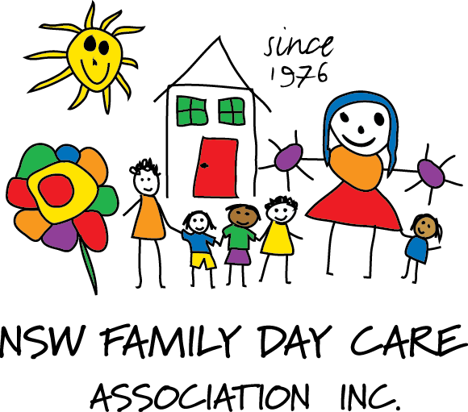

This policy has been adapted from the Example Child Safe Policy of the Office of the Children’s Guardian. www.kidsguardian.nsw.gov.au

